PROJECT :
HOSPITAL MANAGEMENT SYSTEM

GROUP MEMBER:
ZUBAIDA MUHAMMAD NIQAB KHAN
MARYAM SHOAIB
MARYAM GONDAL
ROSHNI RAZA

ASSIGNMENT NO:2

Database Management System
Step 1: Requirement Analysis
Stakeholders
- Patients → Register, book appointments, view reports.
- Doctors → Manage appointments, update patient records, write prescriptions.
- Nurses/Staff → Assist in patient care, update daily checkup records.
- Reception/Admin → Manage appointments, hospital resources, billing.
- Hospital Management → Monitor the system and generate reports.

Functional Requirements
- Patients can sign up, log in, and manage profiles.
- Patients can book or cancel appointments with doctors.
- Doctors can view patient history, update records, and add prescriptions.
- Nurses can update patient vitals and reports.
- Admin can manage doctors, patients, appointments, and billing.
- The system can generate reports (patients list, billing history, doctor schedules).

Non-Functional Requirements
- Performance – Appointment booking should be quick (2–3 seconds).
- Scalability – Should handle more patients, doctors, and hospital departments as the system grows.
- Security – Patient medical records must remain private and secure.
- Availability – System should be available 24/7 with backups.
- Usability – Interface must be simple for patients, doctors, and staff.
- Maintainability – Easy to update when new hospital features or departments are added.

Step 2: Conceptual Design (ERD)
Entities & Attributes
- Patient(PatientID, Name, Age, Gender, Contact, Address, MedicalHistory)
- Doctor(DoctorID, Name, Specialty, Contact, Schedule)
- Appointment(AppointmentID, PatientID, DoctorID, Date, Time, Status)
- Bill(BillID, PatientID, Amount, Date, Status)

Relationships
- One Patient can have many Appointments (1:N).
- One Doctor can have many Appointments (1:N).
- One Patient can have many Bills (1:N).
- One Room will assign to one patient (1:1).

Explanation:
- A Patient books many Appointments.
- A Doctor attends many Appointments.
- A Doctor writes Prescriptions for Patients.
- A Patient receives multiple Bills.

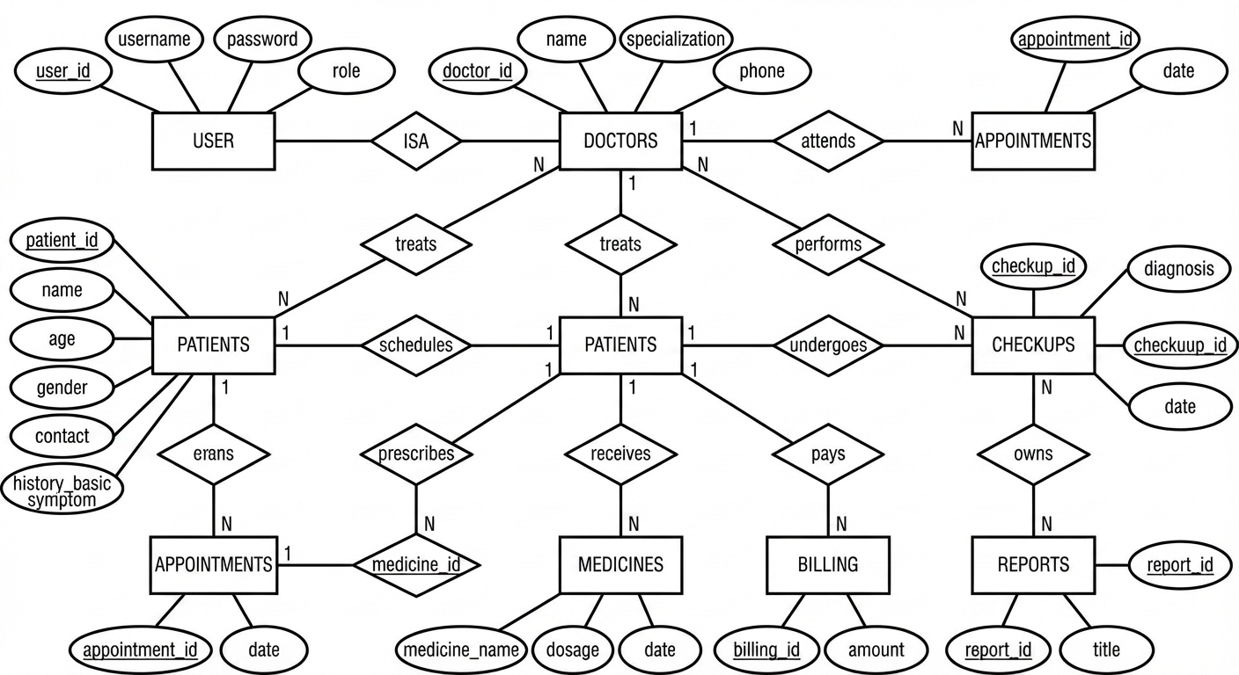

Step 3: Logical Design – Relational Schema

CREATE TABLE Patient (
PatientID INT PRIMARY KEY AUTO_INCREMENT,
Name VARCHAR(100) NOT NULL,
Age INT,
Gender VARCHAR(10),
Contact VARCHAR(50),
Address VARCHAR(255),
MedicalHistory TEXT
);

CREATE TABLE Doctor (
DoctorID INT PRIMARY KEY AUTO_INCREMENT,
Name VARCHAR(100) NOT NULL,
Specialty VARCHAR(100),
Contact VARCHAR(50),
Schedule VARCHAR(100)
);

CREATE TABLE Appointment (
AppointmentID INT PRIMARY KEY AUTO_INCREMENT,
PatientID INT,
DoctorID INT,
Date DATE,
Time TIME,
Status VARCHAR(50),
FOREIGN KEY (PatientID) REFERENCES Patient(PatientID) ON DELETE CASCADE,
FOREIGN KEY (DoctorID) REFERENCES Doctor(DoctorID) ON DELETE CASCADE
);

CREATE TABLE Prescription (
PrescriptionID INT PRIMARY KEY AUTO_INCREMENT,
PatientID INT,
DoctorID INT,
Medicine VARCHAR(255),
Dosage VARCHAR(100),
Date DATE,
FOREIGN KEY (PatientID) REFERENCES Patient(PatientID),
FOREIGN KEY (DoctorID) REFERENCES Doctor(DoctorID)
);

CREATE TABLE Bill (
BillID INT PRIMARY KEY AUTO_INCREMENT,
PatientID INT,
Amount DECIMAL(10,2),
Date DATE,
Status VARCHAR(50),
FOREIGN KEY (PatientID) REFERENCES Patient(PatientID)
);
Final Relational Schema (Summary)
- Patient(PatientID, Name, Age, Gender, Contact, Address, MedicalHistory)
- Doctor(DoctorID, Name, Specialty, Contact, Schedule)
- Appointment(AppointmentID, PatientID FK, DoctorID FK, Date, Time, Status)
- Prescription(PrescriptionID, PatientID FK, DoctorID FK, Medicine, Dosage, Date)
- Bill(BillID, PatientID FK, Amount, Date, Status)

